COLLEGE INFORMATION AND ADMISSIONS WEBSITE

.CODE:
<!DOCTYPE html>
<html lang="en">
<head>
<meta charset="UTF-8">
<meta name="viewport" content="width=device-width, initial-scale=1.0">
<title>NRI College of Technology</title>

<style>
* {
margin: 0;
padding: 0;
box-sizing: border-box;
}

body {
font-family: Arial, sans-serif;
background: #f3f6fc;
color: #16365c;
}

header {
background: #16365c;
color: white;
text-align: center;
padding: 15px;
}

header h2 {
font-size: 24px;
margin-bottom: 8px;
}

nav {
background: #0d2a50;
display: flex;
justify-content: center;
flex-wrap: wrap;
gap: 25px;
padding: 15px;
}

nav a {
color: white;
text-decoration: none;
cursor: pointer;
font-size: 14px;
}

nav a:hover,
nav a.active {
color: #ffc107;
}

section {
display: none;
padding: 35px 20px;
text-align: center;
min-height: 300px;
}

section.active {
display: block;
}

#home {
background: linear-gradient(
rgba(20, 40, 70, 0.7),
rgba(20, 40, 70, 0.7)
), #735448;
color: white;
padding: 80px 20px;
}

h2 {
margin-bottom: 20px;
}

.btn {
display: inline-block;
margin-top: 20px;
padding: 12px 25px;
background: #ffb900;
color: #111;
text-decoration: none;
border: none;
border-radius: 4px;
cursor: pointer;
}
.banner {
background: linear-gradient(
rgba(10, 35, 70, 0.7),
rgba(10, 35, 70, 0.7)
), url("nri college.jpg");
background-size: cover;
background-position: center;
color: white;
text-align: center;
padding: 100px 20px;
}

.container {
max-width: 1000px;
margin: auto;
}

.cards {
display: grid;
grid-template-columns: repeat(
auto-fit, minmax(180px, 1fr)
);
gap: 15px;
margin-top: 25px;
}

.card {
background: white;
padding: 25px 15px;
border-radius: 8px;
box-shadow: 0 2px 6px #00000012;
}

.card h3 {
margin-bottom: 12px;
color: #214a79;
}

.card p {
color: #333;
font-size: 14px;
line-height: 1.6;
}

footer {
background: #0d2a50;
color: white;
text-align: center;
padding: 20px;
}
</style>
</head>

<body>

<header>
<h2>NRI College of Technology</h2>
<p>Knowledge | Innovation | Excellence</p>
</header>

<nav>
<a class="active" onclick="showPage('home', this)">Home</a>
<a onclick="showPage('about', this)">About</a>
<a onclick="showPage('departments', this)">Departments</a>
<a onclick="showPage('faculty', this)">Faculty</a>
<a onclick="showPage('admissions', this)">Admissions</a>
<a onclick="showPage('events', this)">Events</a>
<a onclick="showPage('contact', this)">Contact</a>
</nav>

<!-- HOME -->
<section id="home" class="active">
<div class="banner">
<h1>Welcome to NRI College</h1>
<p>Build Your Future With Quality Education</p>
<button class="btn"
onclick="showPage('admissions')">
Apply Now
</button>
</div>
</section>

<!-- ABOUT -->
<section id="about">
<div class="container">
<h2>About Our College</h2>
<p>
NRI College provides quality education, practical
learning, modern facilities, and career development
opportunities for students.
</p>
</div>
</section>

<!-- DEPARTMENTS -->
<section id="departments">
<div class="container">
<h2>Our Departments</h2>
<div class="cards">
<div class="card">
<h3>Computer Science</h3>
<p>Python, AI, software development and technology.</p>
</div>
<div class="card">
<h3>Electronics</h3>
<p>Electronic circuits and communication systems.</p>
</div>
<div class="card">
<h3>Mechanical</h3>
<p>Machines, manufacturing and engineering design.</p>
</div>
<div class="card">
<h3>Electrical</h3>
<p>Electrical systems, power and renewable energy.</p>
</div>
</div>

<h2 style="margin-top:35px">Popular Courses</h2>
<div class="cards">
<div class="card">
<h3>B.Tech</h3>
<p>Engineering and Technology</p>
</div>
<div class="card">
<h3>B.Sc</h3>
<p>Science and Applied Sciences</p>
</div>
<div class="card">
<h3>BBA</h3>
<p>Business Administration</p>
</div>
</div>
</div>
</section>

<!-- FACULTY -->
<section id="faculty">
<div class="container">
<h2>Our Faculty</h2>
<div class="cards">
<div class="card">
<h3>Prof. Ashwini</h3>
<p>Professor - Python Programming</p>
</div>
<div class="card">
<h3>Prof. Revathi</h3>
<p>Professor - Web Development</p>
</div>
<div class="card">
<h3>Dr. Srinivasulu</h3>
<p>Professor - Mechanical</p>
</div>
</div>
</div>
</section>

<!-- ADMISSIONS -->
<section id="admissions">
<div class="container">
<h2>Admissions</h2>
<p>Join our college and start building your future.</p>
<p>Step 1: Check eligibility</p>
<p>Step 2: Complete the application</p>
<p>Step 3: Submit required documents</p>
<p>Step 4: Complete admission formalities</p>
<button class="btn" onclick="showPage('contact')">
Contact Admissions
</button>
</div>
</section>

<!-- EVENTS -->
<section id="events">
<div class="container">
<h2>College Events</h2>
<div class="cards">
<div class="card">
<h3>Annual Day</h3>
<p>Celebrate student achievements and talents.</p>
</div>
<div class="card">
<h3>Technical Fest</h3>
<p>Explore projects, coding and innovation.</p>
</div>
<div class="card">
<h3>Sports Meet</h3>
<p>Participate in exciting sports competitions.</p>
</div>
</div>
</div>
</section>

<!-- CONTACT -->
<section id="contact">
<div class="container">
<h2>Contact Us</h2>
<p>Address: NRI College of Technology, Andhra Pradesh, India</p>
<p>Email: info@nricollege.com</p>
<p>Phone: +91 98765 43210</p>
</div>
</section>

<footer>
<p>© 2026 NRI College of Technology. All rights reserved.</p>
</footer>

<script>
function showPage(pageId, clickedLink) {
// Hide all sections
document.querySelectorAll("section").forEach(section => {
section.classList.remove("active");
});

// Display only the selected section
document.getElementById(pageId).classList.add("active");

// Update active navigation link
document.querySelectorAll("nav a").forEach(link => {
link.classList.remove("active");
});

// Highlight the clicked menu item
if (clickedLink) {
clickedLink.classList.add("active");
} else {
const matchingLink = [...document.querySelectorAll("nav a")]
.find(link =>
link.getAttribute("onclick")?.includes(
"'" + pageId + "'"
)
);

if (matchingLink) {
matchingLink.classList.add("active");
}
}

// Scroll to the top
window.scrollTo({
top: 0,
behavior: "smooth"
});
}
</script>

</body>
</html>

.OUTPUT: 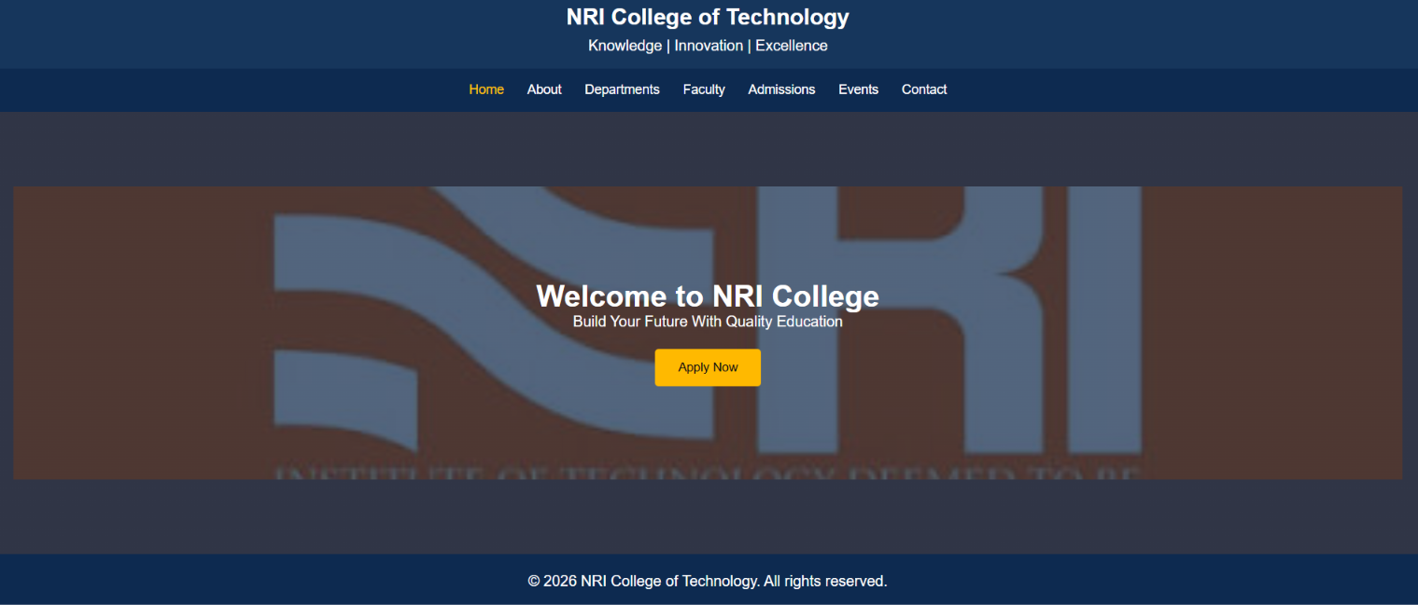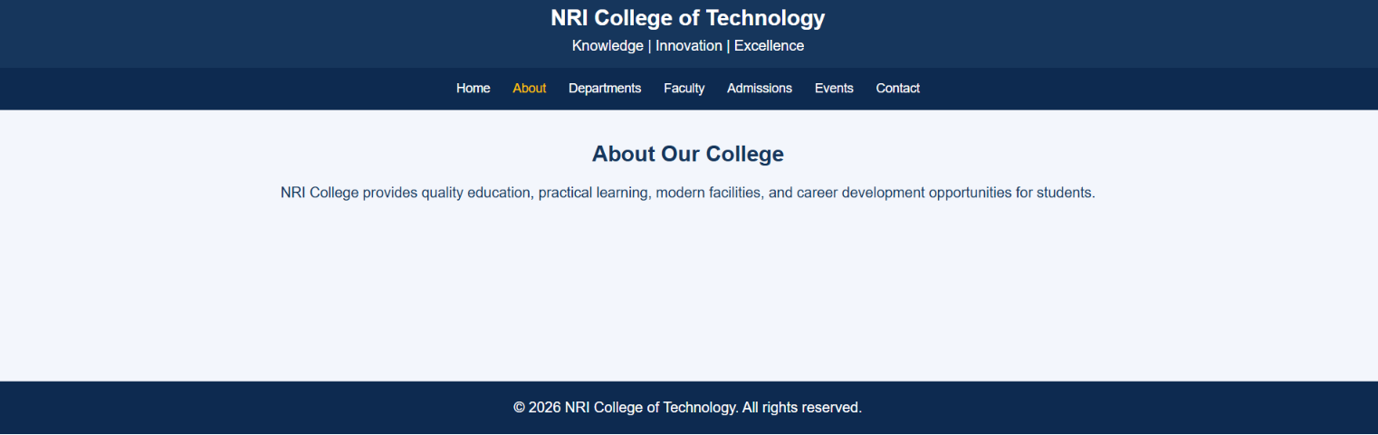
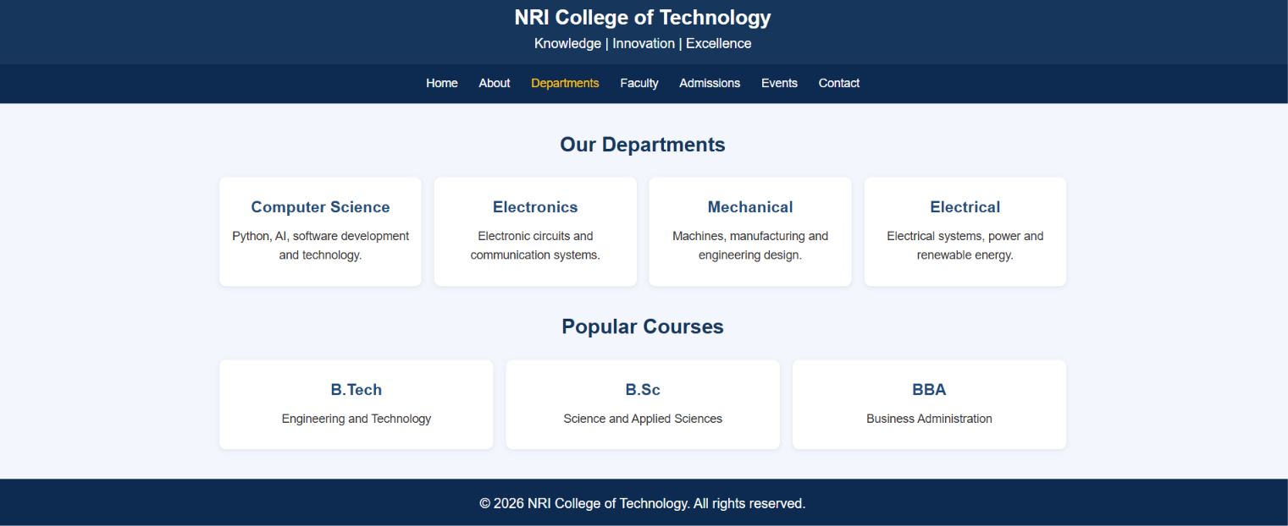

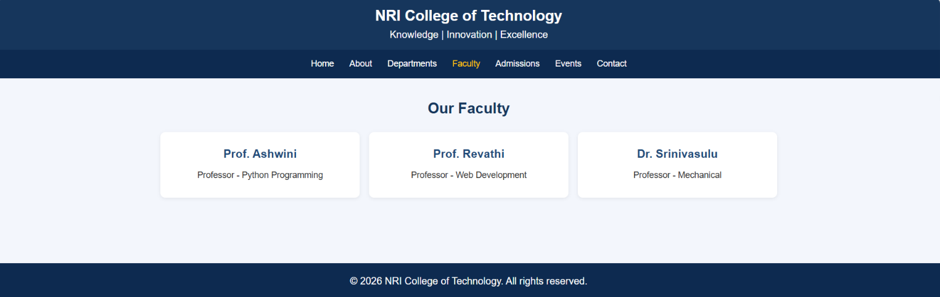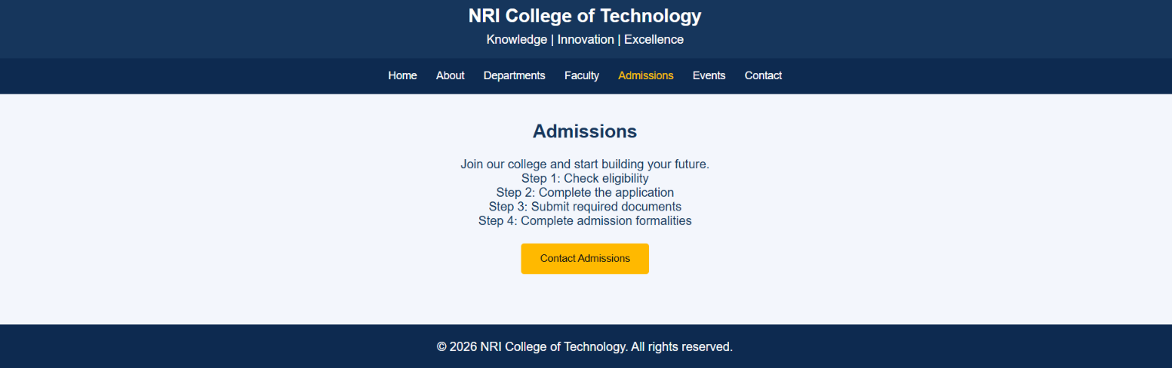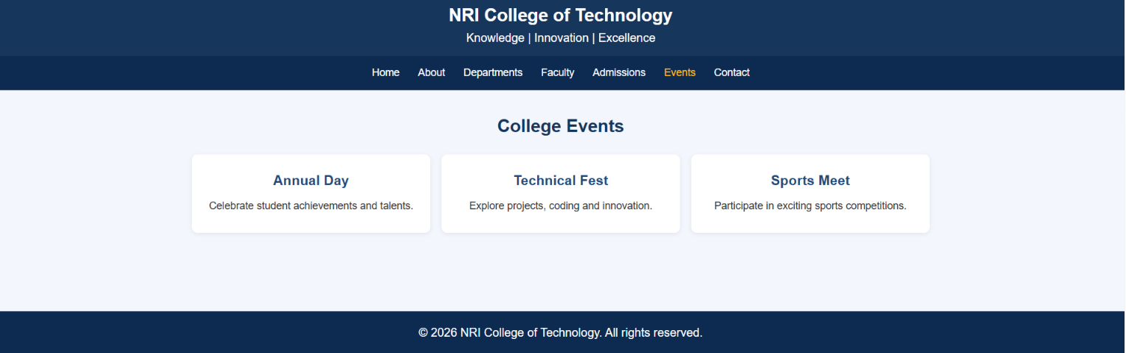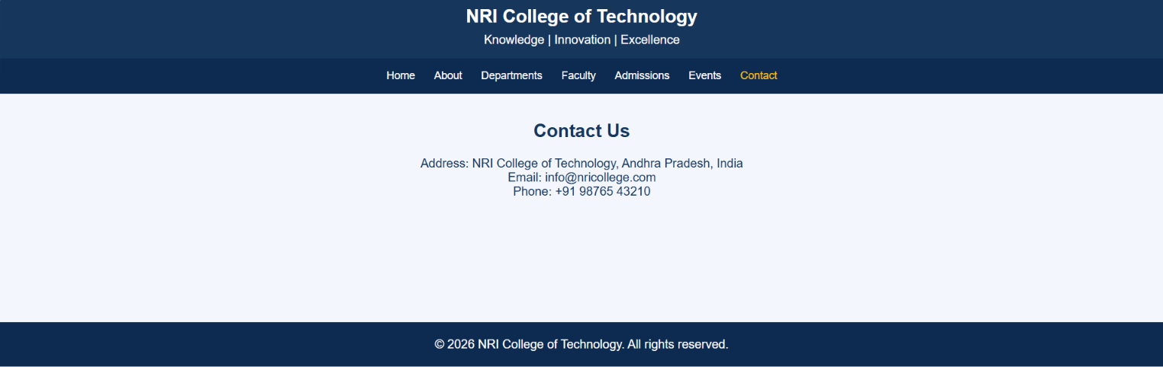

ONLINE SHOPPING WEBSITE

.CODE:

<!DOCTYPE html>
<html lang="en">
<head>
<meta charset="UTF-8">
<meta name="viewport" content="width=device-width, initial-scale=1.0">
<title>ShopEasy - Online Shopping</title>

<style>
* {
margin: 0;
padding: 0;
box-sizing: border-box;
}

body {
font-family: Arial, sans-serif;
background: #f4f6f9;
color: #333;
}

header {
background: #12376b;
color: white;
padding: 20px;
text-align: center;
}

nav {
background: #08264d;
padding: 15px;
text-align: center;
}

nav a {
color: white;
text-decoration: none;
margin: 12px;
font-size: 16px;
display: inline-block;
padding: 5px;
}

nav a:hover,
nav a.active {
color: #ffd700;
}

.banner {
background: linear-gradient(120deg, #1769aa, #12376b);
color: white;
text-align: center;
padding: 60px 20px;
}

.banner h2 {
font-size: 35px;
margin-bottom: 15px;
}

.banner p {
font-size: 18px;
margin: 10px;
}

.shop-btn {
display: inline-block;
background: #ffb703;
color: #12376b;
padding: 12px 25px;
margin-top: 20px;
border-radius: 5px;
text-decoration: none;
font-weight: bold;
}

.shop-btn:hover {
background: #ffd166;
}

section {
padding: 35px 20px;
text-align: center;
}

section h2 {
color: #12376b;
margin-bottom: 25px;
}

/* Hide every page by default */
.page {
display: none;
}

/* Display only the selected page */
.page.active {
display: block;
}

.grid {
display: grid;
grid-template-columns: repeat(
auto-fit, minmax(220px, 1fr)
);
gap: 20px;
max-width: 1100px;
margin: auto;
}

.card {
background: white;
padding: 20px;
border-radius: 10px;
box-shadow: 0 3px 10px #00000015;
transition: transform 0.3s;
}

.card:hover {
transform: translateY(-5px);
}

.product-img {
background: #eaf0ff;
font-size: 60px;
padding: 20px;
border-radius: 8px;
margin-bottom: 15px;
}

.card h3 {
color: #1769aa;
margin-bottom: 10px;
}

.card p {
margin: 8px 0;
}

.rating {
color: #e5a100;
}

.price {
color: #16834a;
font-size: 22px;
font-weight: bold;
}

.old-price {
color: #888;
text-decoration: line-through;
font-size: 14px;
}

.discount {
color: #e63946;
font-weight: bold;
}

.card button {
background: #1769aa;
color: white;
border: none;
padding: 10px 18px;
margin-top: 10px;
border-radius: 5px;
cursor: pointer;
}

.card button:hover {
background: #12376b;
}

.offers {
background: #e1edff;
}

footer {
background: #08264d;
color: white;
text-align: center;
padding: 20px;
}

@media (max-width: 600px) {
.banner h2 {
font-size: 27px;
}

nav a {
margin: 5px;
font-size: 14px;
}
}
</style>
</head>

<body>

<header>
<h1>ShopEasy Online Store</h1>
<p>Quality Products | Best Prices | Happy Shopping</p>
</header>

<!-- Navigation -->
<nav>
<a href="#home" class="active"
onclick="showPage('home', this); return false;">Home</a>

<a href="#categories"
onclick="showPage('categories', this); return false;">Categories</a>

<a href="#products"
onclick="showPage('products', this); return false;">Products</a>

<a href="#offers"
onclick="showPage('offers', this); return false;">Offers</a>

<a href="#contact"
onclick="showPage('contact', this); return false;">Contact</a>
</nav>

<!-- Home Page -->
<section id="home" class="page active">
<div class="banner">
<h2>Welcome to ShopEasy!</h2>
<p>Discover amazing products at affordable prices.</p>
<p>Get up to 40% OFF on selected products!</p>
<a href="#products" class="shop-btn"
onclick="showPage('products', document.querySelectorAll('nav a')[2]); return false;">
Shop Now
</a>
</div>

<h2 style="margin-top: 30px;">Welcome to Our Store</h2>
<p>Explore our categories, products and special offers.</p>
</section>

<!-- Categories Page -->
<section id="categories" class="page">
<h2>Shop by Category</h2>

<div class="grid">
<div class="card">
<div class="product-img">📱</div>
<h3>Electronics</h3>
<p>Mobiles and accessories</p>
</div>

<div class="card">
<div class="product-img">👕</div>
<h3>Fashion</h3>
<p>Clothing and accessories</p>
</div>

<div class="card">
<div class="product-img">👟</div>
<h3>Footwear</h3>
<p>Shoes for every occasion</p>
</div>

<div class="card">
<div class="product-img">🏠</div>
<h3>Home Products</h3>
<p>Useful items for your home</p>
</div>
</div>
</section>

<!-- Products Page -->
<section id="products" class="page">
<h2>Popular Products</h2>

<div class="grid">
<div class="card">
<div class="product-img">🎧</div>
<h3>Wireless Headphones</h3>
<p>Clear sound and comfortable design.</p>
<p class="rating">★★★★★ (4.5)</p>
<p>
<span class="price">₹999</span>
<span class="old-price">₹1499</span>
</p>
<p class="discount">33% OFF</p>
<button type="button"
onclick="addToCart('Wireless Headphones')">
Add to Cart
</button>
</div>

<div class="card">
<div class="product-img">⌚</div>
<h3>Smart Watch</h3>
<p>Track your daily activities easily.</p>
<p class="rating">★★★★★ (4.8)</p>
<p>
<span class="price">₹1999</span>
<span class="old-price">₹2999</span>
</p>
<p class="discount">33% OFF</p>
<button type="button"
onclick="addToCart('Smart Watch')">
Add to Cart
</button>
</div>

<div class="card">
<div class="product-img">👟</div>
<h3>Sports Shoes</h3>
<p>Comfortable shoes for everyday use.</p>
<p class="rating">★★★★☆ (4.3)</p>
<p>
<span class="price">₹1299</span>
<span class="old-price">₹1999</span>
</p>
<p class="discount">35% OFF</p>
<button type="button"
onclick="addToCart('Sports Shoes')">
Add to Cart
</button>
</div>

<div class="card">
<div class="product-img">🎒</div>
<h3>Travel Backpack</h3>
<p>Spacious bag for travel and college.</p>
<p class="rating">★★★★☆ (4.4)</p>
<p>
<span class="price">₹799</span>
<span class="old-price">₹1199</span>
</p>
<p class="discount">33% OFF</p>
<button type="button"
onclick="addToCart('Travel Backpack')">
Add to Cart
</button>
</div>
</div>
</section>

<!-- Offers Page -->
<section id="offers" class="page offers">
<h2>Special Offers</h2>

<div class="grid">
<div class="card">
<h3>🎉 Festival Sale</h3>
<p>Enjoy up to 40% off on selected products.</p>
</div>

<div class="card">
<h3>🚚 Free Delivery</h3>
<p>Free delivery on orders above ₹999.</p>
</div>

<div class="card">
<h3>🔄 Easy Returns</h3>
<p>Easy returns according to store policy.</p>
</div>
</div>
</section>

<!-- Contact Page -->
<section id="contact" class="page">
<h2>Contact Us</h2>
<p>Email: support@shopeasy.com</p>
<p>Phone: +91 98765 43210</p>
</section>

<footer>
<p>&copy; 2026 ShopEasy Online Store. All rights reserved.</p>
<p>Happy Shopping!</p>
</footer>

<script>
function showPage(pageId, clickedLink) {
// Hide all pages
document.querySelectorAll(".page").forEach(page => {
page.classList.remove("active");
});

// Show only the selected page
const selectedPage = document.getElementById(pageId);

if (selectedPage) {
selectedPage.classList.add("active");
}

// Remove active color from all navigation links
document.querySelectorAll("nav a").forEach(link => {
link.classList.remove("active");
});

// Highlight selected navigation link
if (clickedLink) {
clickedLink.classList.add("active");
}

// Scroll to the top
window.scrollTo({
top: 0,
behavior: "smooth"
});
}

function addToCart(productName) {
alert(productName + " added to cart!");
}
</script>

</body>
</html>
.OUTPUT:
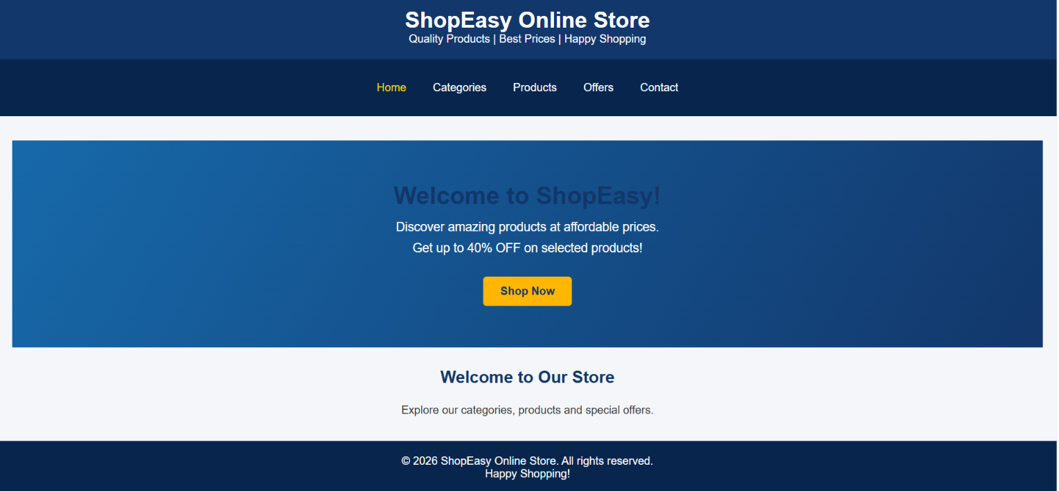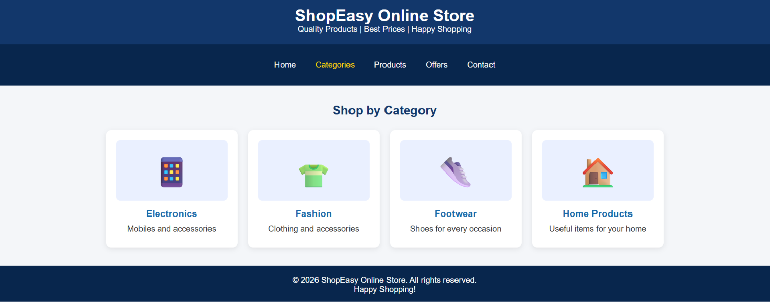

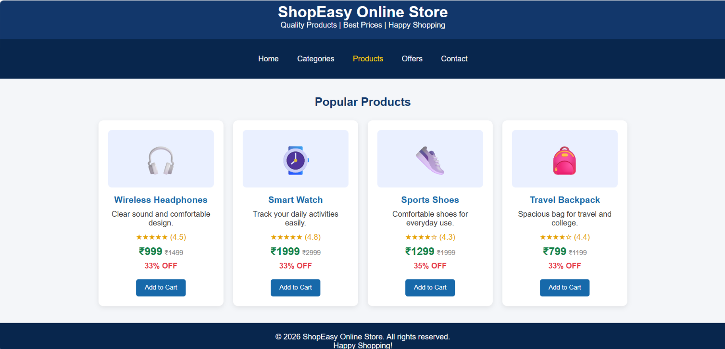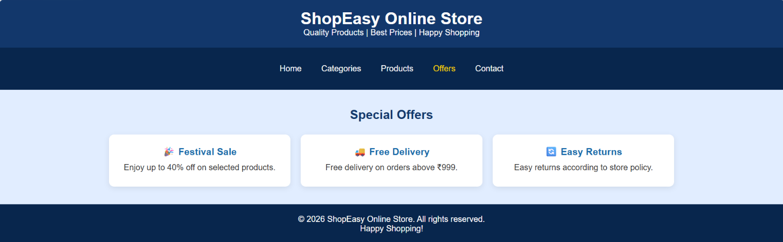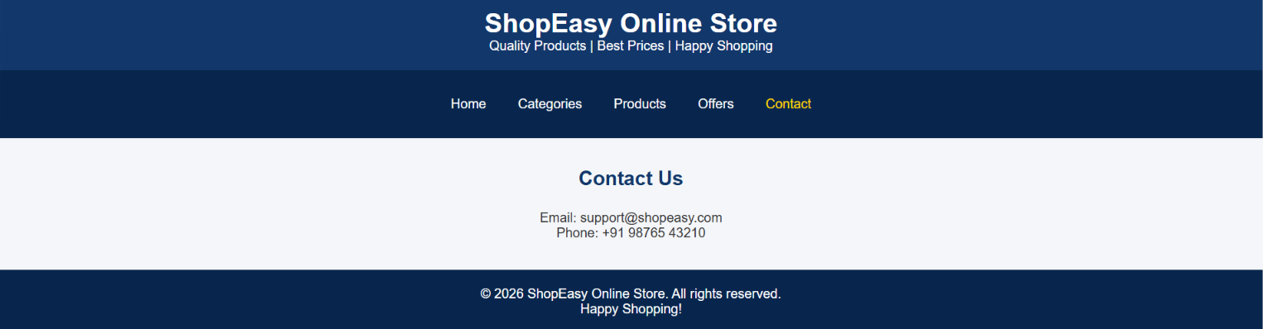

BUS AND TRAIN TICKET BOOKING INTERFACE

.CODE:
<!DOCTYPE html>
<html lang="en">
<head>
<meta charset="UTF-8">
<meta name="viewport" content="width=device-width, initial-scale=1.0">
<title>TravelGo - Ticket Booking</title>

<style>
* {
box-sizing: border-box;
margin: 0;
padding: 0;
}

body {
font-family: Arial, sans-serif;
background: #f0f4f8;
color: #263238;
line-height: 1.5;
}

header {
background: #063970;
color: white;
text-align: center;
padding: 24px 12px;
}

nav {
display: flex;
justify-content: center;
flex-wrap: wrap;
gap: 8px;
background: #0755a5;
padding: 12px;
}

nav button {
margin: 0;
background: transparent;
border: 1px solid #ffffff66;
padding: 10px 14px;
}

nav button:hover,
nav button.active {
background: white;
color: #063970;
}

.container {
width: min(1000px, 92%);
margin: 24px auto;
}

.card {
background: white;
padding: 24px;
margin-bottom: 20px;
border-radius: 10px;
box-shadow: 0 3px 10px #00000012;
}

h2 {
color: #063970;
margin-bottom: 16px;
}

.form-grid {
display: grid;
grid-template-columns: repeat(2, minmax(0, 1fr));
gap: 15px;
}

label {
display: block;
margin-bottom: 6px;
font-weight: bold;
}

input, select {
width: 100%;
padding: 11px;
border: 1px solid #bbb;
border-radius: 5px;
font: inherit;
}

button {
background: #087f5b;
color: white;
border: 0;
padding: 11px 16px;
border-radius: 5px;
cursor: pointer;
margin-top: 12px;
font-size: 15px;
}

button:hover {
background: #056644;
}

.search-btn {
width: 100%;
background: #ff9800;
font-weight: bold;
}

table {
width: 100%;
border-collapse: collapse;
margin-top: 12px;
}

th, td {
border: 1px solid #ddd;
padding: 10px;
text-align: center;
}

th {
background: #0755a5;
color: white;
}

tr:nth-child(even) {
background: #f2f6fa;
}

.table-wrap {
overflow-x: auto;
}

.seats {
display: grid;
grid-template-columns: repeat(4, minmax(45px, 60px));
gap: 12px;
margin-top: 16px;
}

.seat {
padding: 12px 5px;
background: #ddd;
color: #333;
border-radius: 5px;
text-align: center;
cursor: pointer;
border: 0;
margin: 0;
}

.seat.selected {
background: #087f5b;
color: white;
}

.seat.booked {
background: #e74c3c;
color: white;
cursor: not-allowed;
}

.message {
margin-top: 14px;
font-weight: bold;
color: #087f5b;
}

.error {
color: #c0392b;
}

.hidden {
display: none !important;
}

footer {
background: #063970;
color: white;
text-align: center;
padding: 18px;
margin-top: 30px;
}

@media (max-width: 600px) {
.form-grid {
grid-template-columns: 1fr;
}

.card {
padding: 16px;
}

th, td {
padding: 7px 5px;
font-size: 13px;
}
}
</style>
</head>

<body>

<header>
<h1>TravelGo</h1>
<p>Bus and Train Ticket Booking System</p>
</header>

<nav>
<button type="button" class="active"
data-section="booking">Book Tickets</button>

<button type="button"
data-section="services">Available Services</button>

<button type="button"
data-section="seats">Select Seats</button>

<button type="button"
data-section="passenger">Passenger Details</button>
</nav>

<main class="container">

<!-- BOOK TICKETS SECTION -->
<section class="card page-section" id="booking">
<h2>Search Your Journey</h2>

<form id="searchForm">
<div class="form-grid">

<div>
<label for="source">From</label>
<input id="source" type="text"
placeholder="Enter source city" required>
</div>

<div>
<label for="destination">To</label>
<input id="destination" type="text"
placeholder="Enter destination city" required>
</div>

<div>
<label for="date">Travel Date</label>
<input id="date" type="date" required>
</div>

<div>
<label for="type">Travel Type</label>
<select id="type">
<option value="All">Bus and Train</option>
<option value="Bus">Bus</option>
<option value="Train">Train</option>
</select>
</div>

<div>
<label for="count">Passengers</label>
<select id="count">
<option value="1">1 Passenger</option>
<option value="2">2 Passengers</option>
<option value="3">3 Passengers</option>
<option value="4">4 Passengers</option>
<option value="5">5 Passengers</option>
</select>
</div>

</div>

<button class="search-btn" type="submit">
Search Buses and Trains
</button>
</form>

<p id="searchMessage" class="message"></p>
</section>

<!-- AVAILABLE SERVICES SECTION -->
<section class="card page-section hidden" id="services">
<h2>Available Services</h2>
<p id="routeSummary"></p>

<div class="table-wrap">
<table>
<thead>
<tr>
<th>Service</th>
<th>Type</th>
<th>Departure</th>
<th>Arrival</th>
<th>Fare / Person</th>
<th>Action</th>
</tr>
</thead>

<tbody id="serviceList">

<tr data-type="Bus" data-fare="650">
<td>Express Bus</td>
<td>Bus</td>
<td>08:00 AM</td>
<td>02:00 PM</td>
<td>₹650</td>
<td>
<button type="button"
class="choose-service">Select</button>
</td>
</tr>

<tr data-type="Train" data-fare="450">
<td>Superfast Express</td>
<td>Train</td>
<td>09:30 AM</td>
<td>03:30 PM</td>
<td>₹450</td>
<td>
<button type="button"
class="choose-service">Select</button>
</td>
</tr>

<tr data-type="Bus" data-fare="900">
<td>Luxury AC Bus</td>
<td>Bus</td>
<td>10:00 PM</td>
<td>05:00 AM</td>
<td>₹900</td>
<td>
<button type="button"
class="choose-service">Select</button>
</td>
</tr>

<tr data-type="Train" data-fare="750">
<td>Intercity Express</td>
<td>Train</td>
<td>06:00 PM</td>
<td>11:00 PM</td>
<td>₹750</td>
<td>
<button type="button"
class="choose-service">Select</button>
</td>
</tr>

</tbody>
</table>
</div>

<p id="serviceMessage" class="message"></p>

<button type="button" id="continueSeats" class="hidden">
Continue to Select Seats
</button>
</section>

<!-- SEAT SELECTION SECTION -->
<section class="card page-section hidden" id="seats">
<h2>Select Your Seats</h2>

<p>Select the required number of seats.</p>

<div class="seats" id="seatLayout">
<button type="button" class="seat">A1</button>
<button type="button" class="seat">A2</button>
<button type="button" class="seat booked" disabled>A3</button>
<button type="button" class="seat">A4</button>

<button type="button" class="seat">B1</button>
<button type="button" class="seat booked" disabled>B2</button>
<button type="button" class="seat">B3</button>
<button type="button" class="seat">B4</button>

<button type="button" class="seat">C1</button>
<button type="button" class="seat">C2</button>
<button type="button" class="seat">C3</button>
<button type="button" class="seat">C4</button>
</div>

<p style="margin-top:15px">
🟩 Selected &nbsp; ⬜ Available &nbsp; 🟥 Booked
</p>

<p id="seatMessage" class="message">
Selected seats: None
</p>

<button type="button" id="continuePassenger">
Continue to Passenger Details
</button>
</section>

<!-- PASSENGER DETAILS SECTION -->
<section class="card page-section hidden" id="passenger">
<h2>Passenger Details</h2>

<form id="passengerForm">
<div class="form-grid">

<div>
<label for="name">Full Name</label>
<input id="name" type="text"
placeholder="Enter full name" required>
</div>

<div>
<label for="age">Age</label>
<input id="age" type="number" min="1" max="120"
placeholder="Enter age" required>
</div>

<div>
<label for="gender">Gender</label>
<select id="gender" required>
<option value="">Select gender</option>
<option>Male</option>
<option>Female</option>
<option>Other</option>
</select>
</div>

<div>
<label for="phone">Mobile Number</label>
<input id="phone" type="tel"
pattern="[0-9]{10}" maxlength="10"
placeholder="10-digit mobile number" required>
</div>

</div>

<h3 style="margin-top:20px">Fare Summary</h3>
<p id="fareSummary">
Select a service to see the fare.
</p>

<button type="submit">Confirm Booking</button>
</form>

<p id="bookingMessage" class="message"></p>
</section>

</main>

<footer>
<p>&copy; 2026 TravelGo | Bus and Train Ticket Booking</p>
</footer>

<script>
const navButtons = document.querySelectorAll(
'nav button[data-section]'
);

const sections = document.querySelectorAll('.page-section');

let selectedService = null;
let selectedSeats = [];
let passengerCount = 1;

let route = {
source: '',
destination: '',
date: '',
type: 'All'
};

/* Show only the section that was clicked */
function showSection(sectionId) {
sections.forEach(section => {
section.classList.toggle(
'hidden',
section.id !== sectionId
);
});

navButtons.forEach(button => {
const active = button.dataset.section === sectionId;

button.classList.toggle('active', active);
button.setAttribute(
'aria-current',
active ? 'page' : 'false'
);
});

document.getElementById(sectionId).scrollIntoView({
behavior: 'smooth',
block: 'start'
});
}

/* Navigation button clicks */
navButtons.forEach(button => {
button.addEventListener('click', () => {
showSection(button.dataset.section);
});
});

/* Search journey */
document.getElementById('searchForm')
.addEventListener('submit', function(event) {
event.preventDefault();

route.source = document.getElementById('source').value.trim();
route.destination =
document.getElementById('destination').value.trim();
route.date = document.getElementById('date').value;
route.type = document.getElementById('type').value;

passengerCount = Number(
document.getElementById('count').value
);

const searchMessage =
document.getElementById('searchMessage');

if (
route.source.toLowerCase() ===
route.destination.toLowerCase()
) {
searchMessage.textContent =
'From and To cities must be different.';
searchMessage.classList.add('error');
return;
}

searchMessage.classList.remove('error');
searchMessage.textContent =
'Search complete. Select an available service.';

document.getElementById('routeSummary').textContent =
`${route.source} → ${route.destination} | ` +
`Date: ${route.date} | Passengers: ${passengerCount}`;

/* Filter bus/train services */
document.querySelectorAll('#serviceList tr')
.forEach(row => {
row.classList.toggle(
'hidden',
route.type !== 'All' &&
row.dataset.type !== route.type
);
});

selectedService = null;
selectedSeats = [];

document.getElementById('serviceMessage').textContent = '';
document.getElementById('continueSeats')
.classList.add('hidden');
document.getElementById('bookingMessage').textContent = '';

updateSeats();
updateFare();

showSection('services');
});

/* Select a bus or train */
document.querySelectorAll('.choose-service')
.forEach(button => {
button.addEventListener('click', function() {
const row = this.closest('tr');

selectedService = {
name: row.cells[0].textContent,
type: row.dataset.type,
fare: Number(row.dataset.fare)
};

document.getElementById('serviceMessage').textContent =
`Selected: ${selectedService.name} — ` +
`₹${selectedService.fare} per passenger.`;

document.getElementById('continueSeats')
.classList.remove('hidden');

updateFare();
});
});

/* Continue to seats */
document.getElementById('continueSeats')
.addEventListener('click', function() {
if (!selectedService) {
document.getElementById('serviceMessage').textContent =
'Please select a service first.';
return;
}

showSection('seats');
});

/* Update selected seat display */
function updateSeats() {
document.querySelectorAll(
'#seatLayout .seat:not(.booked)'
).forEach(seat => {
seat.classList.toggle(
'selected',
selectedSeats.includes(seat.textContent.trim())
);
});

document.getElementById('seatMessage').textContent =
`Selected seats: ${
selectedSeats.length
? selectedSeats.join(', ')
: 'None'
} (${selectedSeats.length}/${passengerCount})`;
}

/* Select or deselect seats */
document.querySelectorAll(
'#seatLayout .seat:not(.booked)'
).forEach(seat => {
seat.addEventListener('click', function() {
const name = this.textContent.trim();

if (selectedSeats.includes(name)) {
selectedSeats = selectedSeats.filter(
item => item !== name
);
} else if (selectedSeats.length < passengerCount) {
selectedSeats.push(name);
} else {
document.getElementById('seatMessage').textContent =
`You can select only ${passengerCount} seat(s).`;
return;
}

updateSeats();
});
});

/* Continue to passenger details */
document.getElementById('continuePassenger')
.addEventListener('click', function() {
if (!selectedService) {
document.getElementById('seatMessage').textContent =
'Please choose a service first.';
showSection('services');
return;
}

if (selectedSeats.length !== passengerCount) {
document.getElementById('seatMessage').textContent =
`Please select exactly ${passengerCount} seat(s).`;
return;
}

showSection('passenger');
updateFare();
});

/* Calculate total fare */
function updateFare() {
const summary = document.getElementById('fareSummary');

if (!selectedService) {
summary.textContent =
'Select a service to see the fare.';
return;
}

summary.textContent =
`${selectedService.name} | ${passengerCount} passenger(s) × ` +
`₹${selectedService.fare} = ` +
`₹${passengerCount * selectedService.fare}`;
}

/* Confirm demo booking */
document.getElementById('passengerForm')
.addEventListener('submit', function(event) {
event.preventDefault();

const message = document.getElementById('bookingMessage');

if (!selectedService ||
selectedSeats.length !== passengerCount) {
message.classList.add('error');
message.textContent =
'Please select a service and the required seats first.';
return;
}

const name = document.getElementById('name').value.trim();

message.classList.remove('error');
message.textContent =
`Demo booking confirmed for ${name}. ` +
`Service: ${selectedService.name}. ` +
`Seats: ${selectedSeats.join(', ')}. ` +
`Total: ₹${passengerCount * selectedService.fare}. ` +
'This demo does not issue a real ticket.';
});

/* Set minimum travel date to today */
const dateInput = document.getElementById('date');
const today = new Date();
const localToday = [
today.getFullYear(),
String(today.getMonth() + 1).padStart(2, '0'),
String(today.getDate()).padStart(2, '0')
].join('-');

dateInput.min = localToday;
dateInput.value = localToday;
</script>

</body>
</html>

.OUTPUT:



